Jules Voltaire

[javoltaire@wpi.edu](mailto:javoltaire@wpi.edu)

Project 2

**User Analysis:** The users will consist of programmers, computer enthusiasts, students; Mostly people that are new to Linux.

**Task Analysis:**

* Objects
  + Buttons
    - Icons
    - Background Color
  + Labels
  + Textboxes
    - Border Color when Selected
  + ScrollViewer
  + ListBox/ListView
  + Headers
  + Link Labels
* Actions
  + Clicking a button
  + Adding character to a textbox
  + Scrolling
  + Clicking a link
* Examples
  + User adds a sequences of characters in the search textbox and clicks the search button.
  + User clicks on one of the command categories, e.g. Files and Directories to select it and see all the commands for that category.
  + User Clicks on one of the commands to see more details about that command
  + User scrolls down to see the remaining commands in the selected category.
  + User clicks the Back button to go back to the main page.

This is main page where the user is able to select categories and see different commands and a short description of each command. On the page the user is able to click on each command to see more details, and examples.

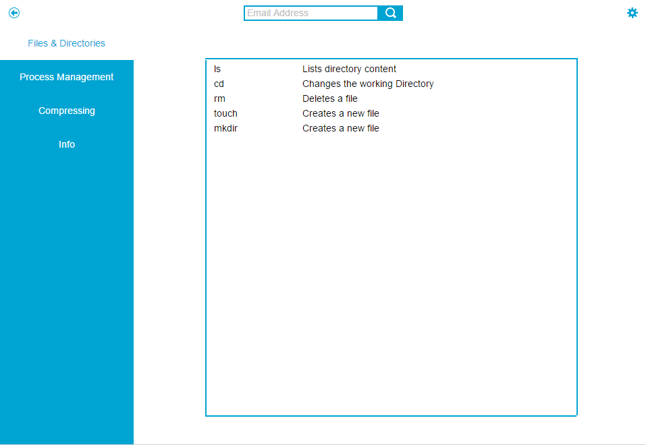

On this page the user user will be able to see more details about a command. Users will also be able to see the other commands that are in the same category.

